Protected Attributes – UN Definition
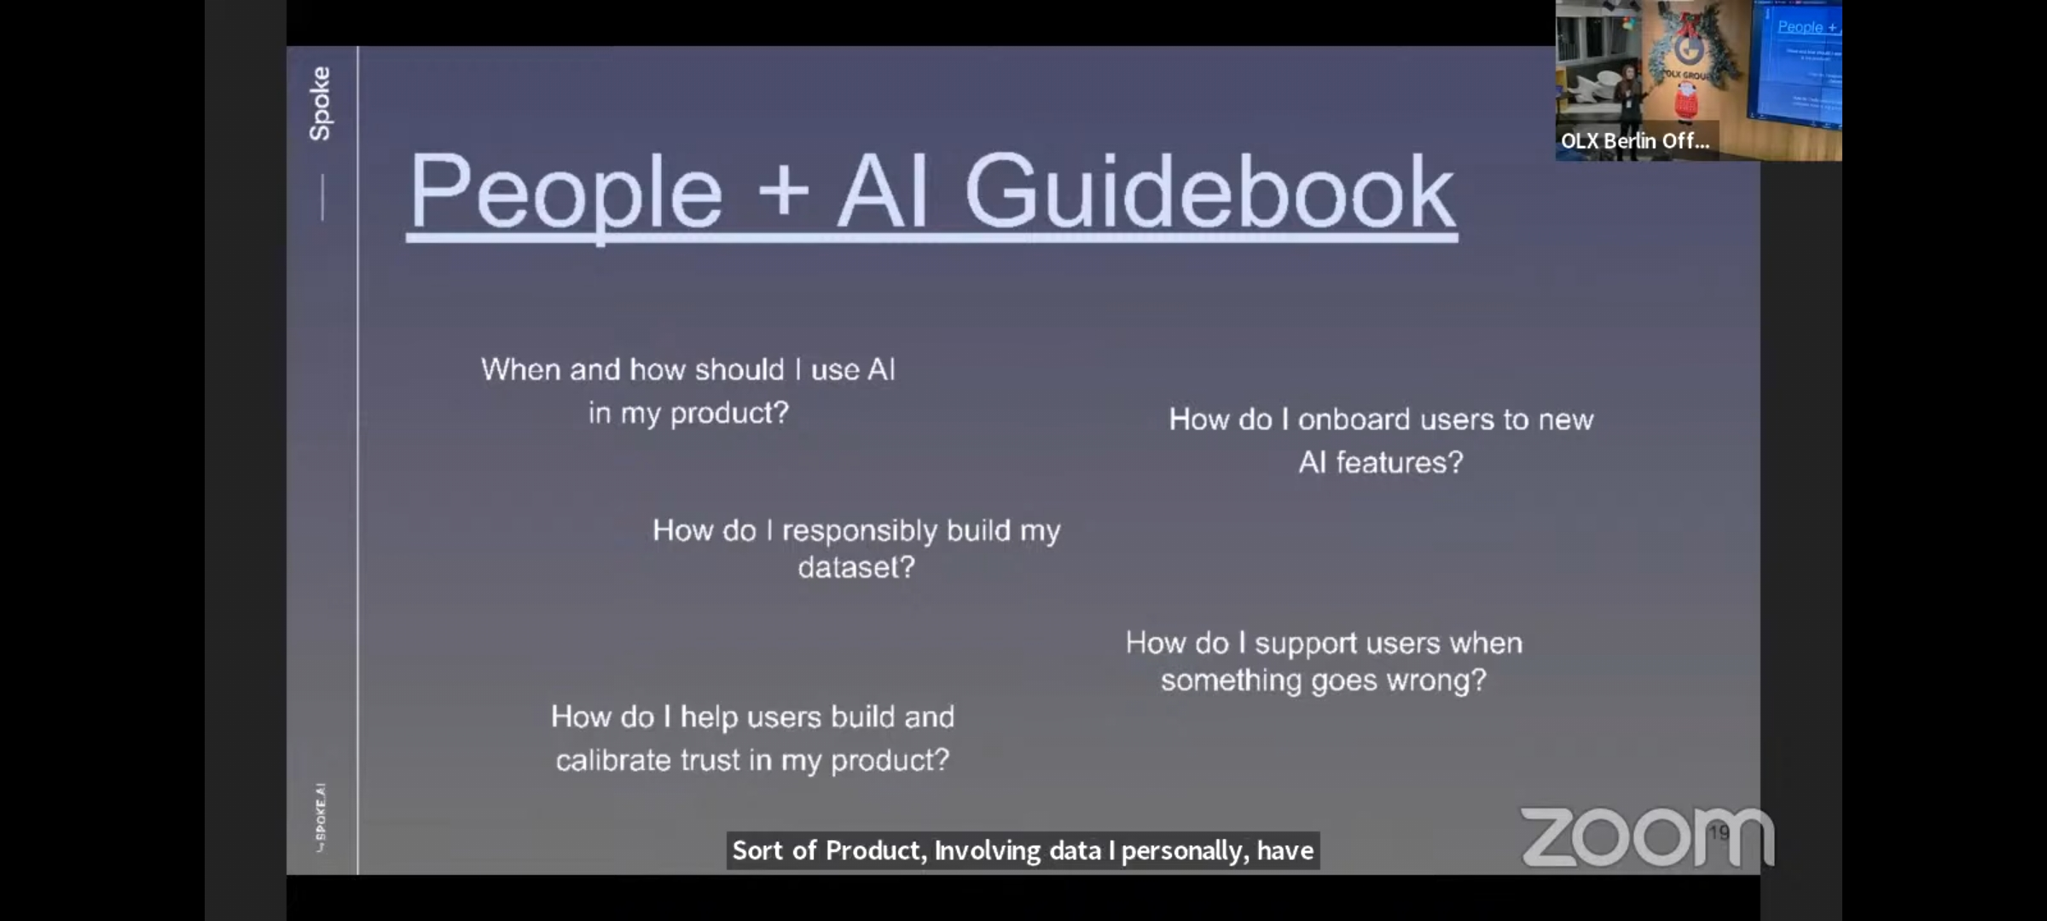
Philosophy Tube – In the airport, if you fail the metal check, security would ask you to step in a machine that scans your whole body for hidden objects. To do this the security officer has to enter one of two options, male or female, all done based on the security guards bias on what the searched person looks like. The problem starts when ones gender is non conforming, as such if the security guard were to press male while female, then it would detect a dangerous item because for the system, a female should not have something down there (and vice-versa), not to mention those that have both. This is easily solved by asking the other person what gender they are, BUT that comes with ethical questions…
